**WEEK 7**

**EXERCISE 9: Cricket App**

**CODE:**

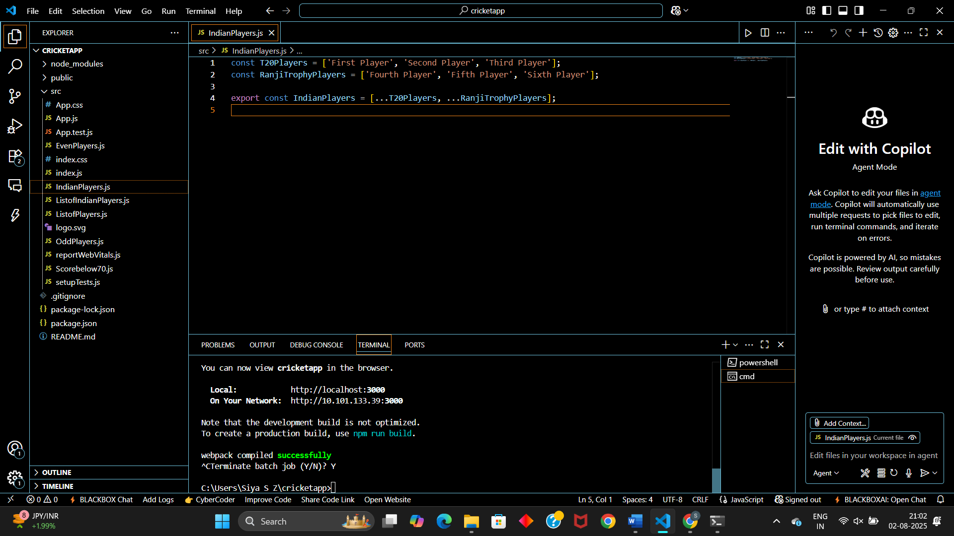

**App.js**  
import React from 'react';

import ListofPlayers from './ListofPlayers';

import Scorebelow70 from './Scorebelow70';

import { IndianPlayers } from './IndianPlayers';

import OddPlayers from './OddPlayers';

import EvenPlayers from './EvenPlayers';

import ListofIndianPlayers from './ListofIndianPlayers';

const players = [

  { name: 'Jack', score: 50 },

  { name: 'Michael', score: 70 },

  { name: 'John', score: 40 },

  { name: 'Ann', score: 61 },

  { name: 'Elisabeth', score: 61 },

  { name: 'Sachin', score: 95 },

  { name: 'Dhoni', score: 100 },

  { name: 'Virat', score: 84 },

  { name: 'Jadeja', score: 64 },

  { name: 'Raina', score: 75 },

  { name: 'Rohit', score: 80 }

];

const Indian_Team = ['Sachin 1', 'Dhoni2', 'Virat3', 'Rohit4', 'Yuvarajs', 'Raina6'];

let flag = true;

function App() {

  if (flag === true) {

    return (

      <div>

        <h1>List of Players</h1>

        <ListofPlayers players={players} />

        <hr />

        <h1>List of Players having Scores Less than 70</h1>

        <Scorebelow70 players={players} />

      </div>

    );

  } else {

    return (

      <div>

        <h1>Odd Players</h1>

        {OddPlayers(Indian_Team)}

        <hr />

        <h1>Even Players</h1>

        {EvenPlayers(Indian_Team)}

        <hr />

        <h1>List of Indian Players Merged:</h1>

        <ListofIndianPlayers IndianPlayers={IndianPlayers} />

      </div>

    );

  }

}

export default App;

**ListofPlayers.js:**  
import React from 'react';

function ListofPlayers({ players }) {

  return (

    <ul>

      {players.map((item) => (

        <div key={item.name}>

          <li>Mr. {item.name} <span>{item.score}</span></li>

        </div>

      ))}

    </ul>

  );

}

export default ListofPlayers;

**IndianPlayers.js:**  
const T20Players = ['First Player', 'Second Player', 'Third Player'];

const RanjiTrophyPlayers = ['Fourth Player', 'Fifth Player', 'Sixth Player'];

export const IndianPlayers = [...T20Players, ...RanjiTrophyPlayers];

**ListofIndianPlayers.js:**import React from 'react';

function ListofIndianPlayers({ IndianPlayers }) {

  return (

    <ul>

      {IndianPlayers.map((player, index) => (

        <li key={index}>{player}</li>

      ))}

    </ul>

  );

}

export default ListofIndianPlayers;

**EvenPlayers.js:**  
export default function EvenPlayers([, second, , fourth, , sixth]) {

  return (

    <div>

      <li>Second: {second}</li>

      <li>Fourth: {fourth}</li>

      <li>Sixth: {sixth}</li>

    </div>

  );

}

**OddPlayers.js:**  
export default function OddPlayers([first, , third, , fifth]) {

  return (

    <div>

      <li>First: {first}</li>

      <li>Third: {third}</li>

      <li>Fifth: {fifth}</li>

    </div>

  );

}

**Scorebelow70.js:**  
import React from 'react';

function Scorebelow70({ players }) {

  const filtered = players.filter((item) => item.score < 70);

  return (

    <ul>

      {filtered.map((item) => (

        <div key={item.name}>

          <li>Mr. {item.name} <span>{item.score}</span></li>

        </div>

      ))}

    </ul>

  );

}

export default Scorebelow70;

**RESULT:**

When Flag = False  
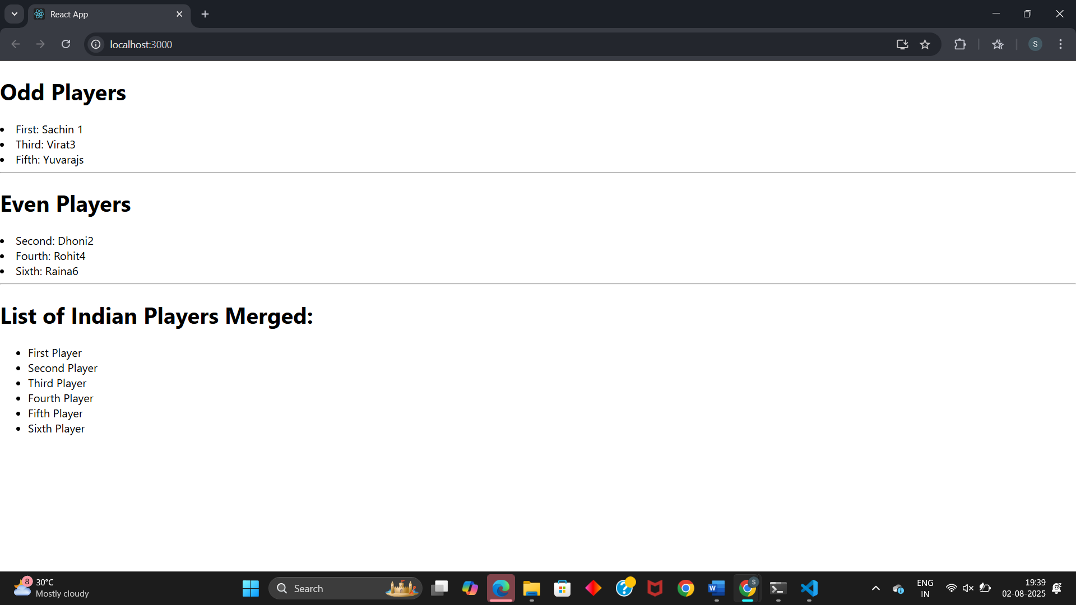

When Flag = True:  
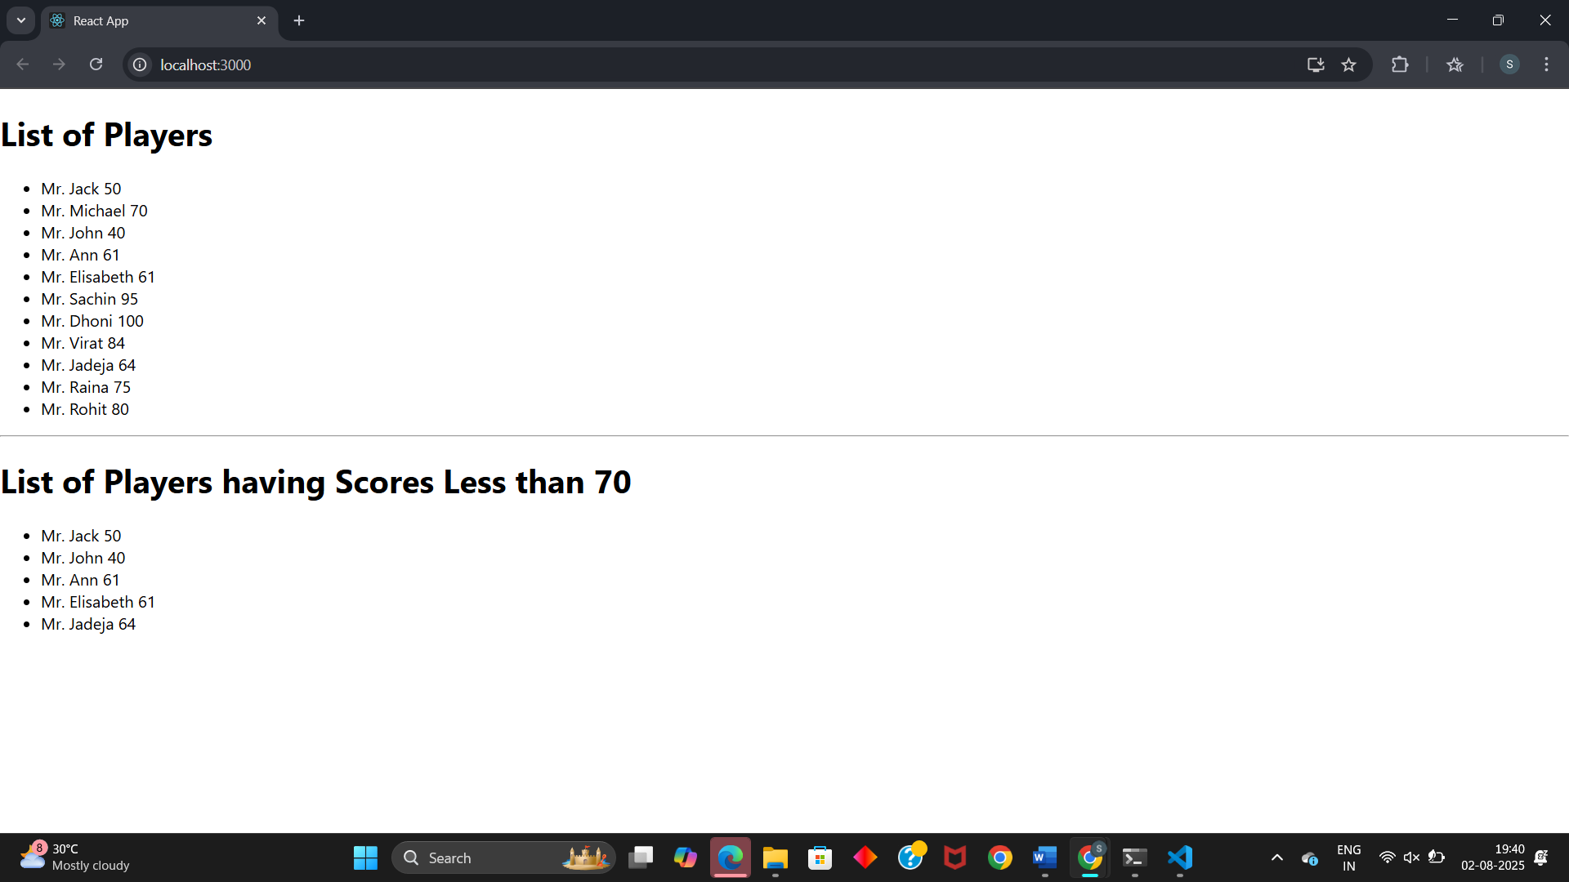

**EXERCISE 10: Office Space Rental App**

**CODE:**

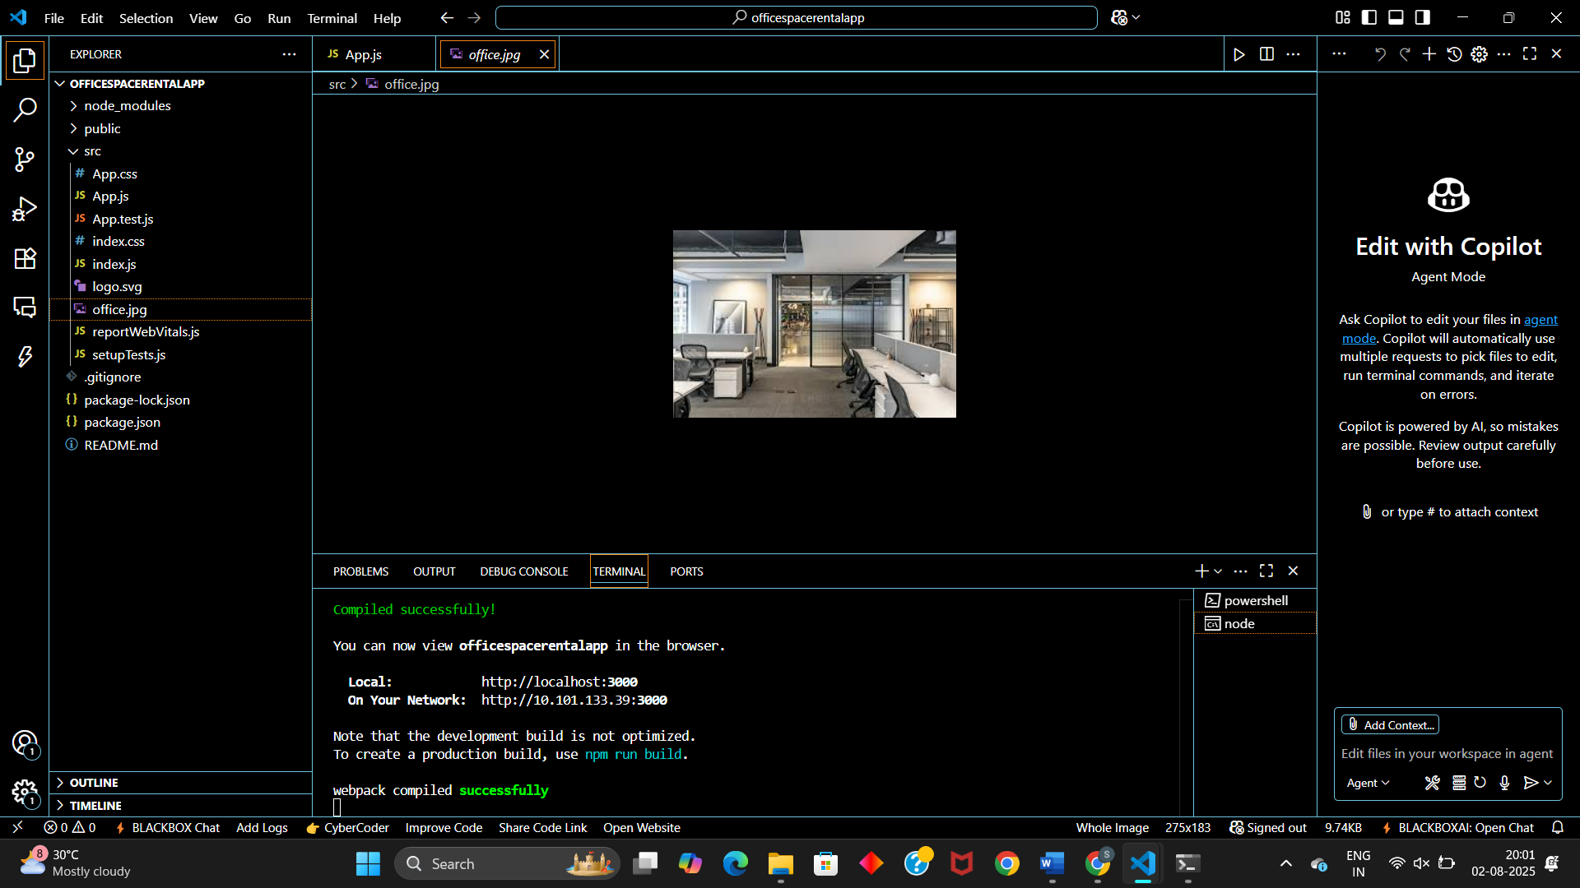

**App.js:**  
import React from 'react';

import officeImage from './office.jpg';

function App() {

  const officeList = [

    { Name: "ABC", Rent: 500000, Address: "Chennai" },

  ];

  return (

    <div style={{ padding: '20px', fontFamily: 'Arial' }}>

      <h1 style={{ fontWeight: 'bold' }}>Office Space , at Affordable Range</h1>

      {officeList.map((item, index) => {

        const rentColor = item.Rent <= 60000 ? 'red' : 'green';

        return (

          <div key={index} style={{ marginBottom: '40px' }}>

            <img

              src={officeImage}

              alt="Office Space"

              style={{ width: '25%', height: '25%' }}

            />

            <h2>Name: {item.Name}</h2>

            <h3 style={{ color: rentColor }}>Rent: Rs. {item.Rent}</h3>

            <h3>Address: {item.Address}</h3>

          </div>

        );

      })}

    </div>

  );

}

export default App;

**RESULT:**

Below 60000  
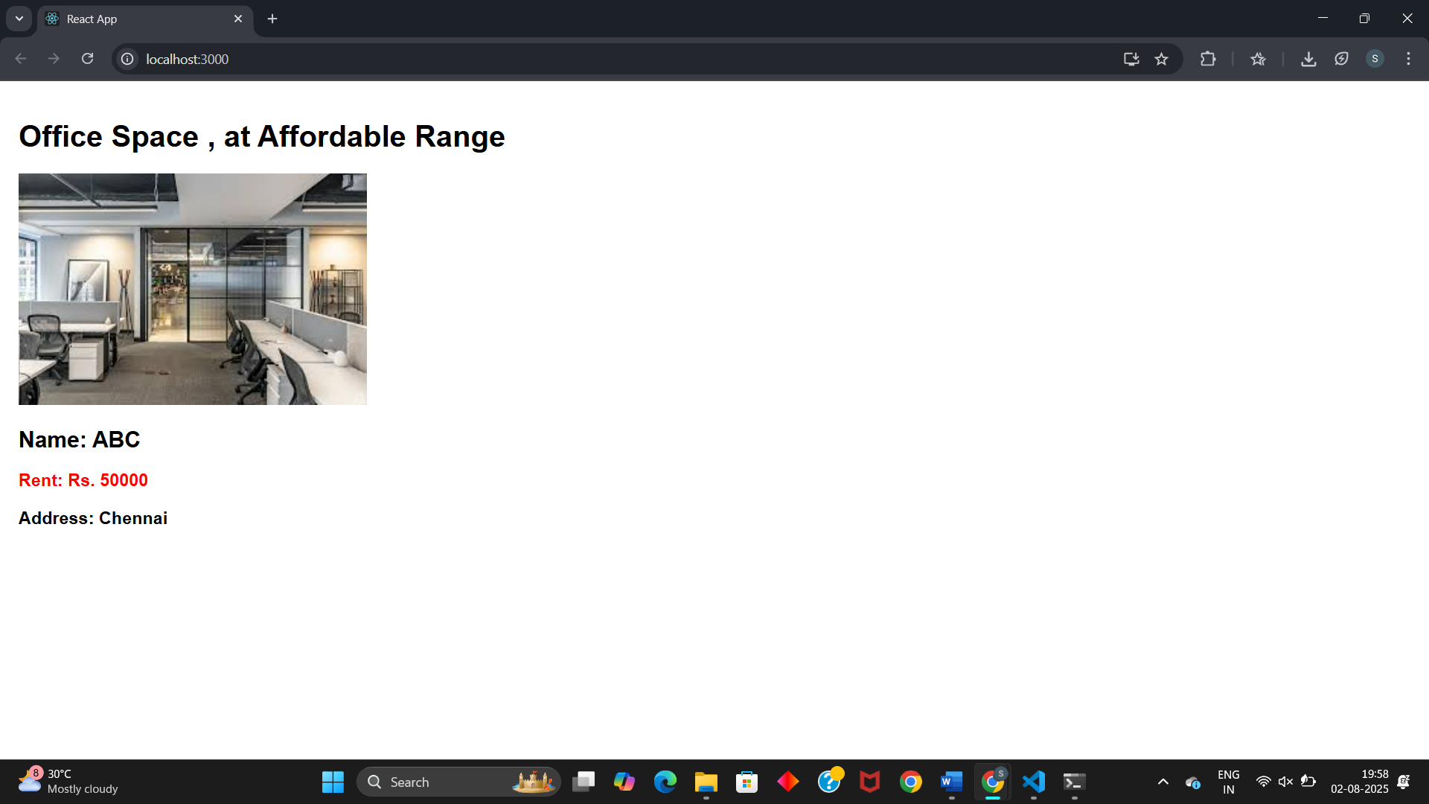

Above 60000  
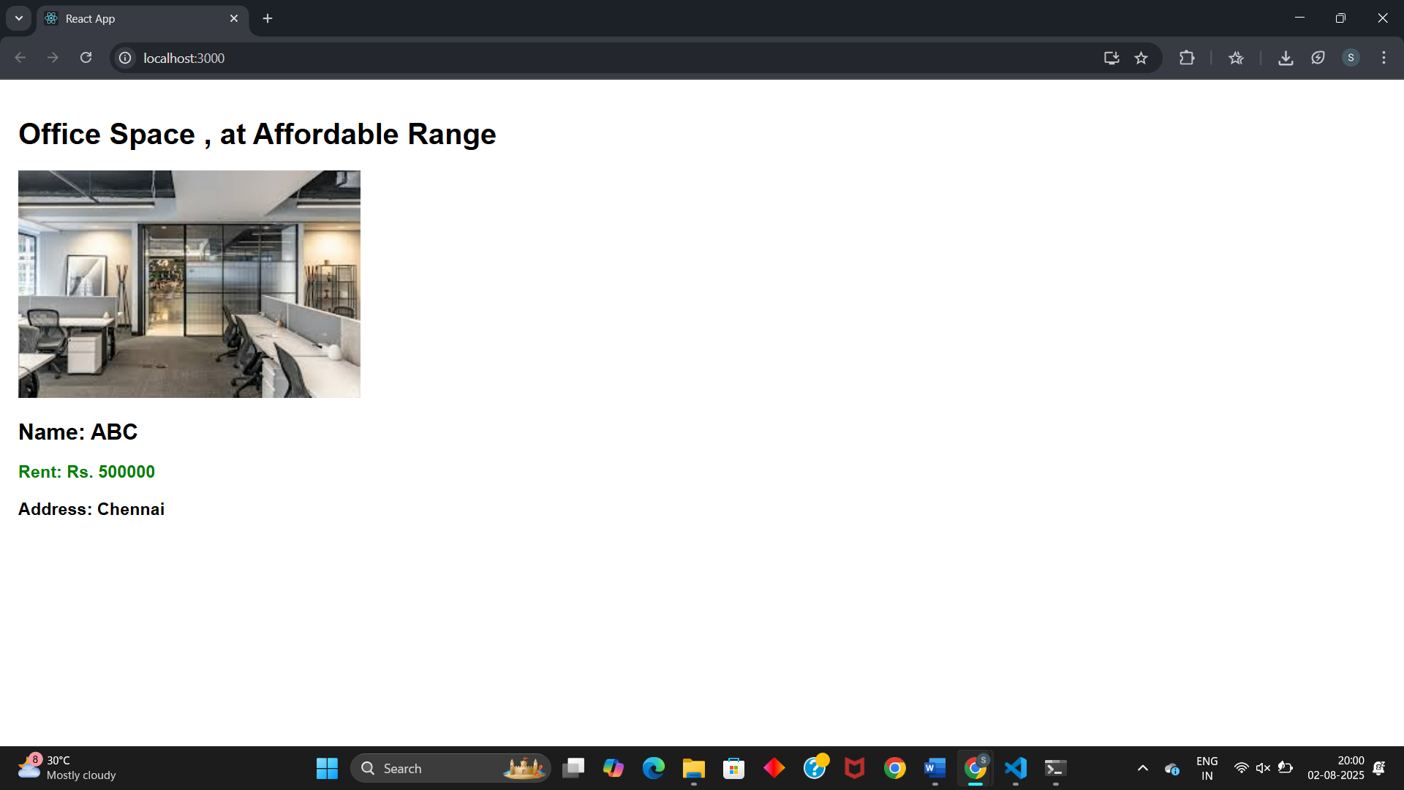

**EXERCISE 11: Event Examples App**

**CODE:**

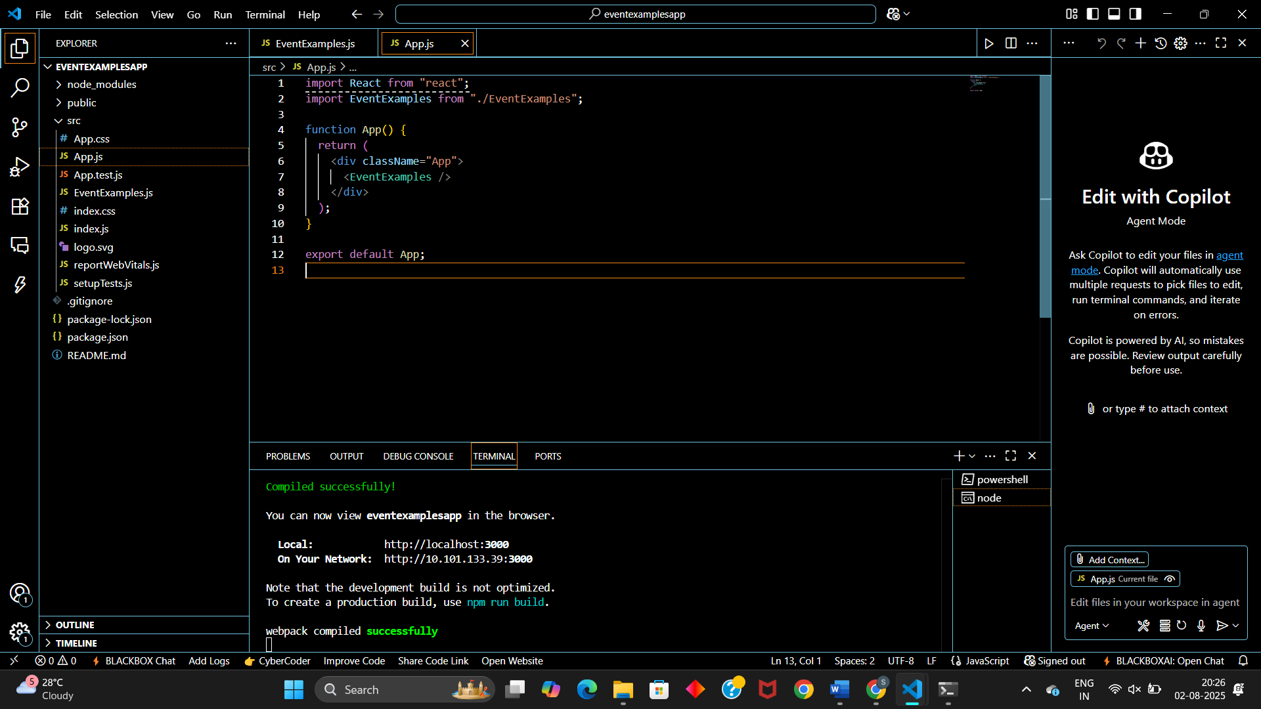

**App.js:**  
import React from "react";

import EventExamples from "./EventExamples";

function App() {

  return (

    <div className="App">

      <EventExamples />

    </div>

  );

}

export default App;

**EventExamples.js:**  
import React from "react";

class EventExamples extends React.Component {

  constructor() {

    super();

    this.state = {

      count: 0,

      amount: "",

      currency: "",

    };

    this.handleIncrement = this.handleIncrement.bind(this);

    this.handleDecrement = this.handleDecrement.bind(this);

    this.sayWelcome = this.sayWelcome.bind(this);

    this.handleClick = this.handleClick.bind(this);

    this.handleSubmit = this.handleSubmit.bind(this);

    this.handleAmountChange = this.handleAmountChange.bind(this);

    this.handleCurrencyChange = this.handleCurrencyChange.bind(this);

  }

  handleIncrement() {

    this.setState((prevState) => ({ count: prevState.count + 1 }));

    this.sayHello();

  }

  handleDecrement() {

    this.setState((prevState) => ({ count: prevState.count - 1 }));

  }

  sayHello() {

    alert("Hello! You clicked increment.");

  }

  sayWelcome(msg) {

    alert(`Welcome Message: ${msg}`);

  }

  handleClick(e) {

    e.preventDefault();

    alert("I was clicked!");

  }

  handleAmountChange(e) {

    this.setState({ amount: e.target.value });

  }

  handleCurrencyChange(e) {

    this.setState({ currency: e.target.value });

  }

  handleSubmit(e) {

    e.preventDefault();

    const { amount, currency } = this.state;

    if (currency.toLowerCase() === "euro") {

      const converted = parseFloat(amount) * 0.0125; // 1 INR = 0.0125 EUR (you can change this)

      alert(`Converting to Euro, the amount is = €${converted.toFixed(2)}`);

    } else {

      alert("Conversion for the entered currency is not supported.");

    }

  }

  render() {

    return (

      <div style={{ margin: "20px", fontFamily: "Arial" }}>

        <h2>{this.state.count}</h2>

        <div style={{ marginBottom: "10px" }}>

          <button onClick={this.handleIncrement}>Increment</button>

        </div>

        <div style={{ marginBottom: "10px" }}>

          <button onClick={this.handleDecrement}>Decrement</button>

        </div>

        <div style={{ marginBottom: "10px" }}>

          <button onClick={() => this.sayWelcome("Welcome to React!")}>

            Say welcome

          </button>

        </div>

        <div style={{ marginBottom: "20px" }}>

          <button onClick={this.handleClick}>Click on me</button>

        </div>

        <h1 style={{ color: "green" }}>Currency Convertor!!!</h1>

        <form onSubmit={this.handleSubmit}>

          <label>

            Amount (INR):&nbsp;

            <input

              type="number"

              value={this.state.amount}

              onChange={this.handleAmountChange}

              required

            />

          </label>

          <br />

          <br />

          <label>

            Currency:&nbsp;

            <input

              type="text"

              value={this.state.currency}

              onChange={this.handleCurrencyChange}

              placeholder="e.g. Euro"

              required

            />

          </label>

          <br />

          <br />

          <button type="submit">Submit</button>

        </form>

      </div>

    );

  }

}

export default EventExamples;

**RESULT:**

Increment:  
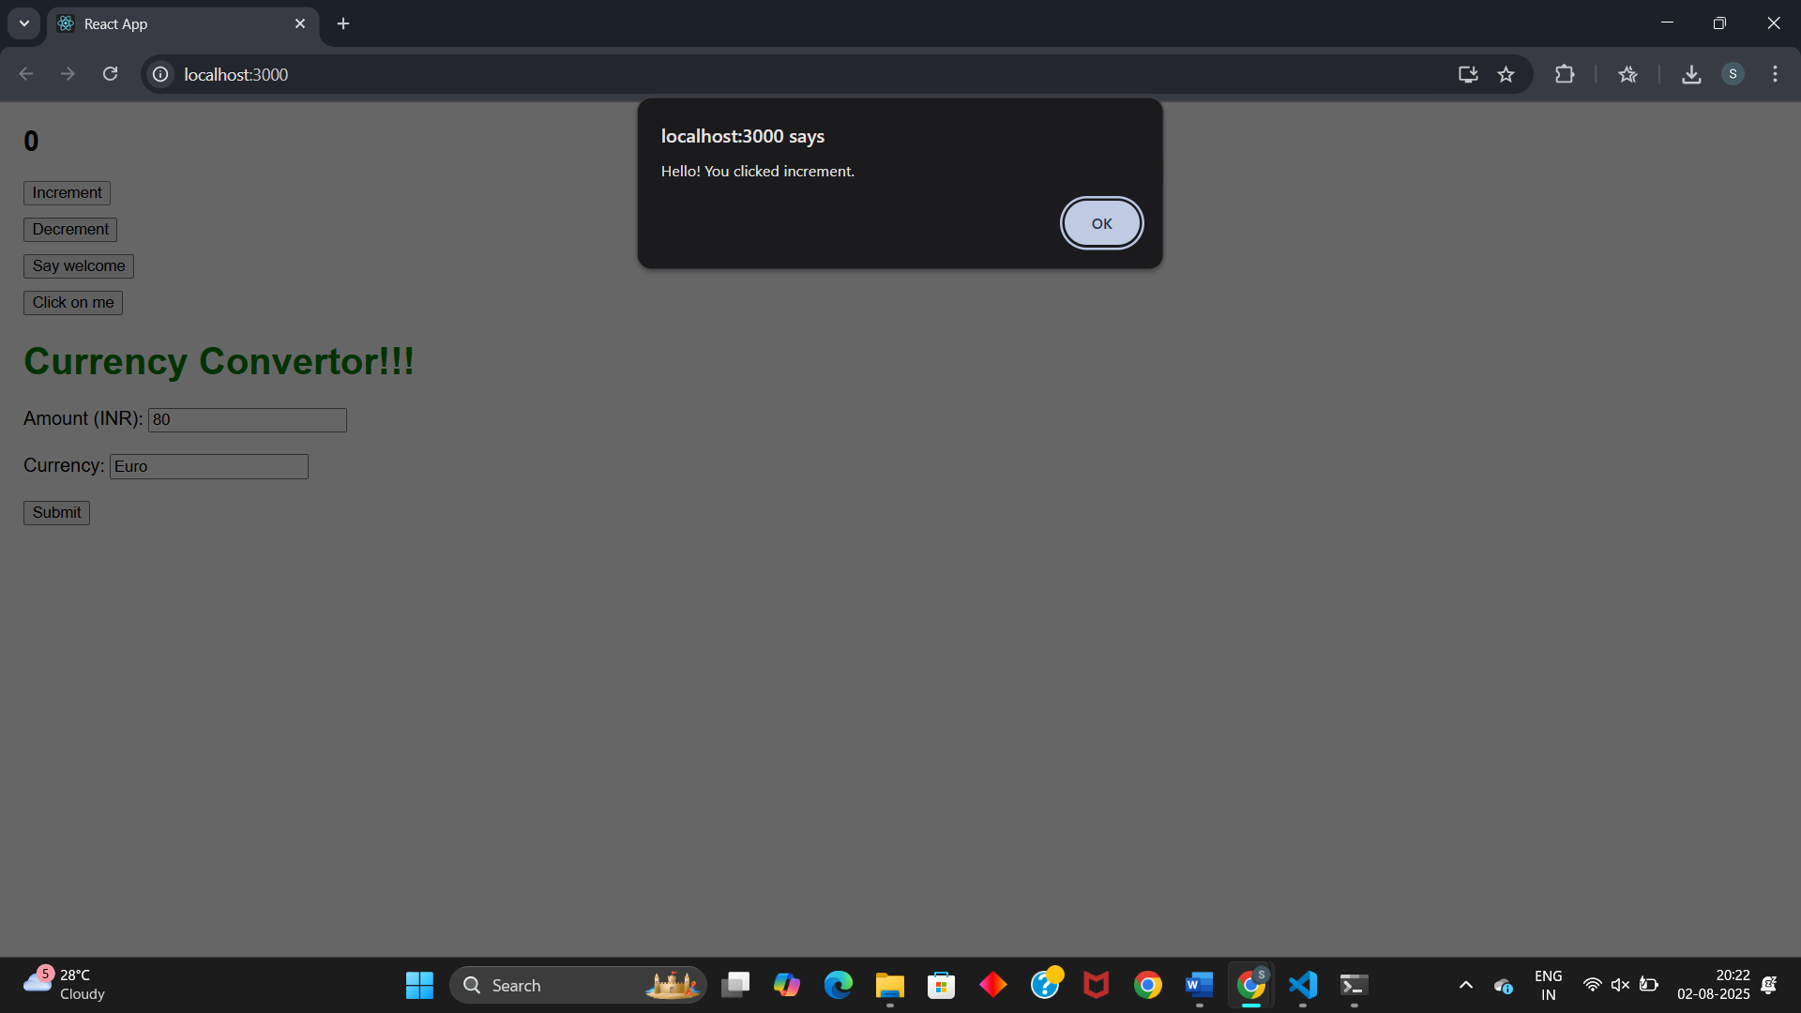

Say Welcome:  
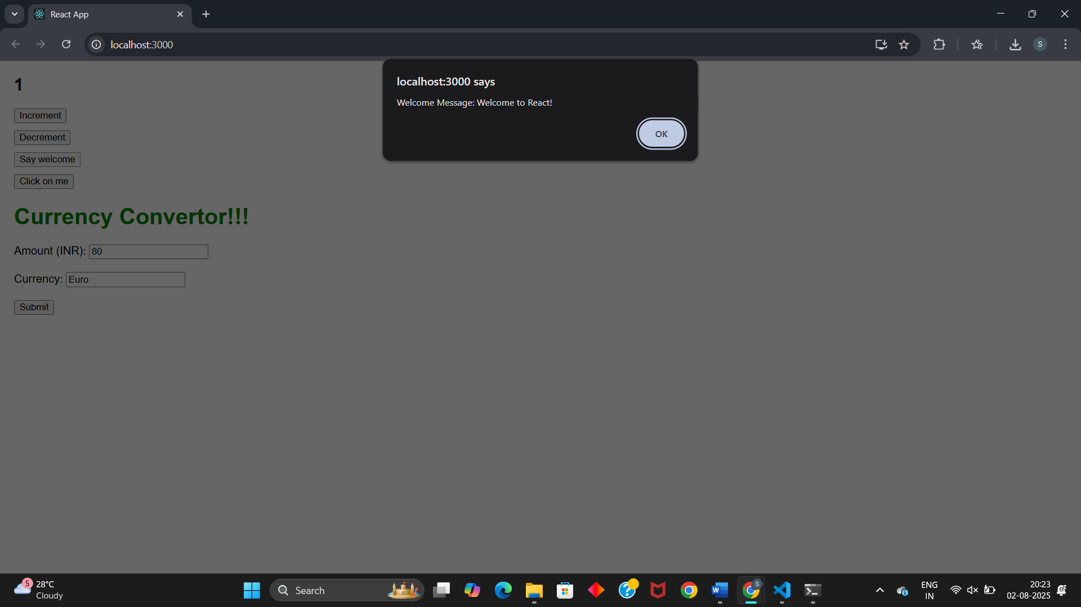

Click on me:  
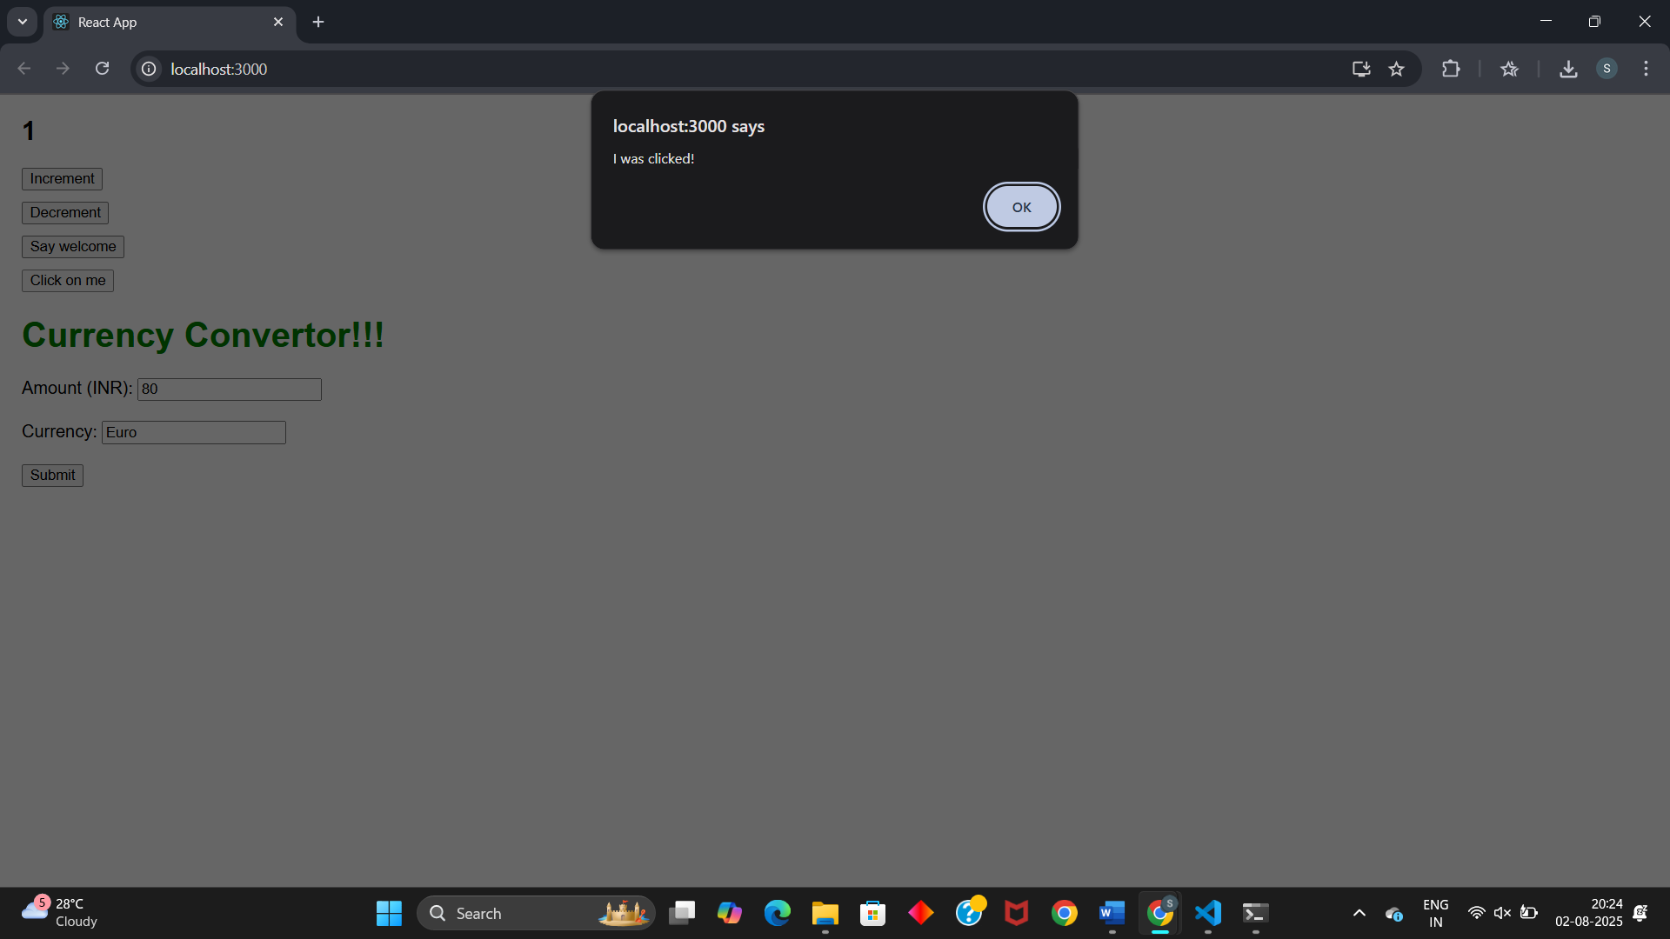

Currency Convertor:  
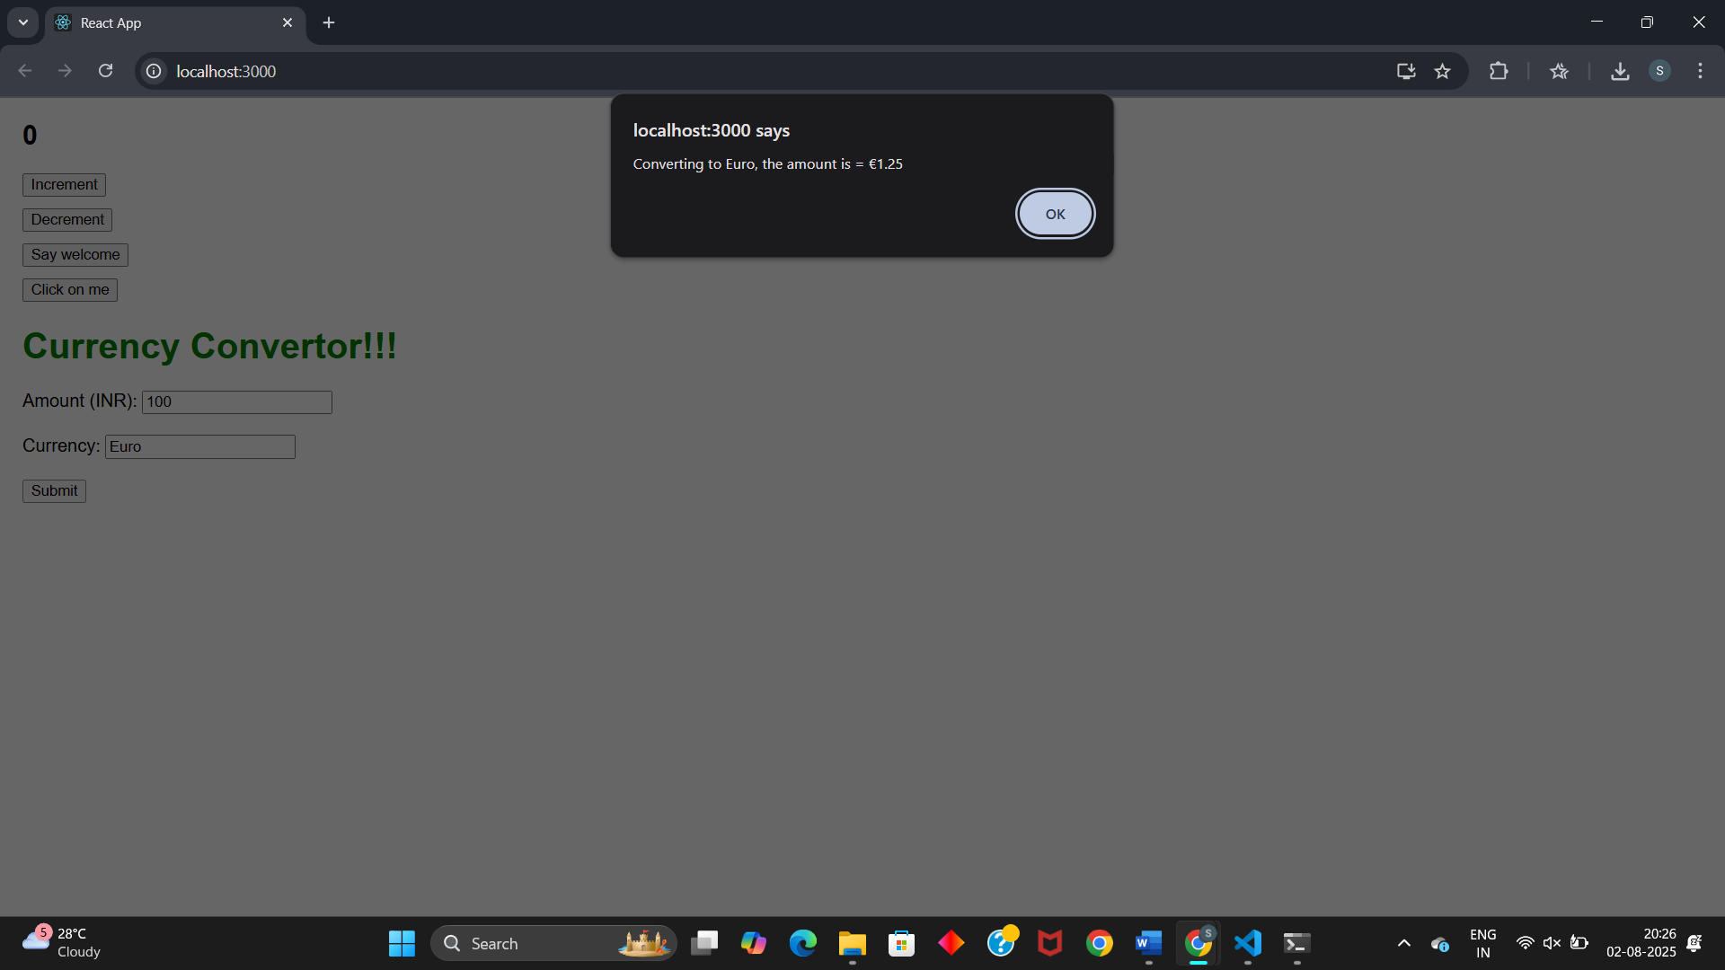

**EXERCISE 12: Ticket Booking App**

**CODE:**

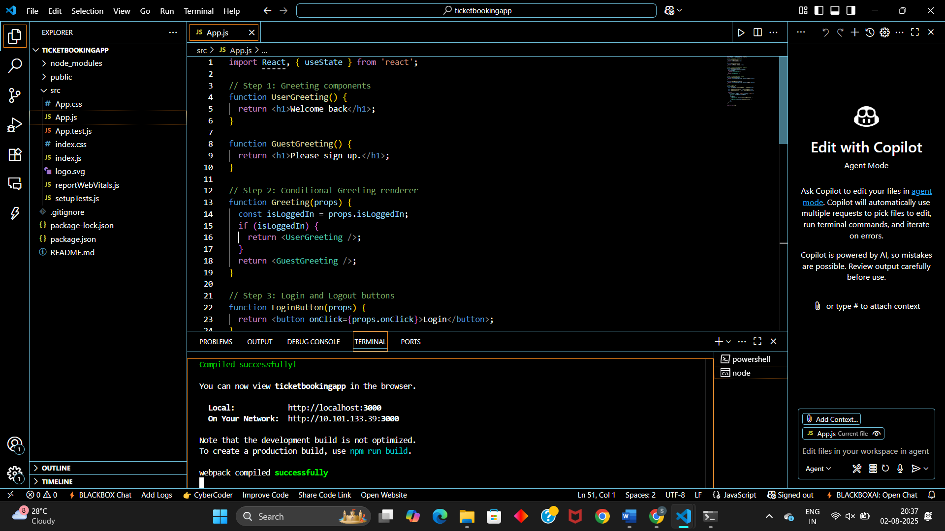

**App.js**  
import React, { useState } from 'react';

// Step 1: Greeting components

function UserGreeting() {

  return <h1>Welcome back</h1>;

}

function GuestGreeting() {

  return <h1>Please sign up.</h1>;

}

// Step 2: Conditional Greeting renderer

function Greeting(props) {

  const isLoggedIn = props.isLoggedIn;

  if (isLoggedIn) {

    return <UserGreeting />;

  }

  return <GuestGreeting />;

}

// Step 3: Login and Logout buttons

function LoginButton(props) {

  return <button onClick={props.onClick}>Login</button>;

}

function LogoutButton(props) {

  return <button onClick={props.onClick}>Logout</button>;

}

// Step 4: Main App

function App() {

  const [isLoggedIn, setIsLoggedIn] = useState(false);

  const handleLoginClick = () => setIsLoggedIn(true);

  const handleLogoutClick = () => setIsLoggedIn(false);

  return (

    <div style={{ margin: "100px", fontSize: "24px" }}>

      <Greeting isLoggedIn={isLoggedIn} />

      <br />

      {isLoggedIn ? (

        <LogoutButton onClick={handleLogoutClick} />

      ) : (

        <LoginButton onClick={handleLoginClick} />

      )}

    </div>

  );

}

export default App;

**RESULT:**

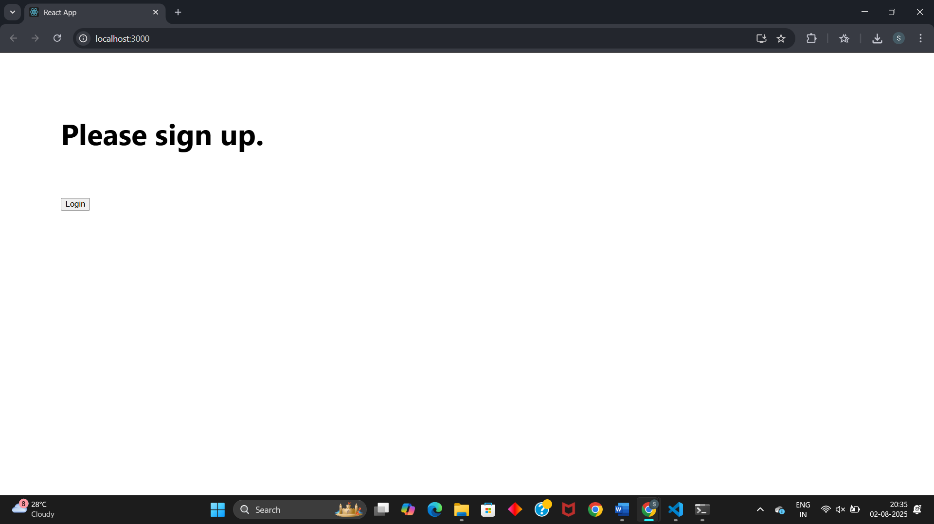

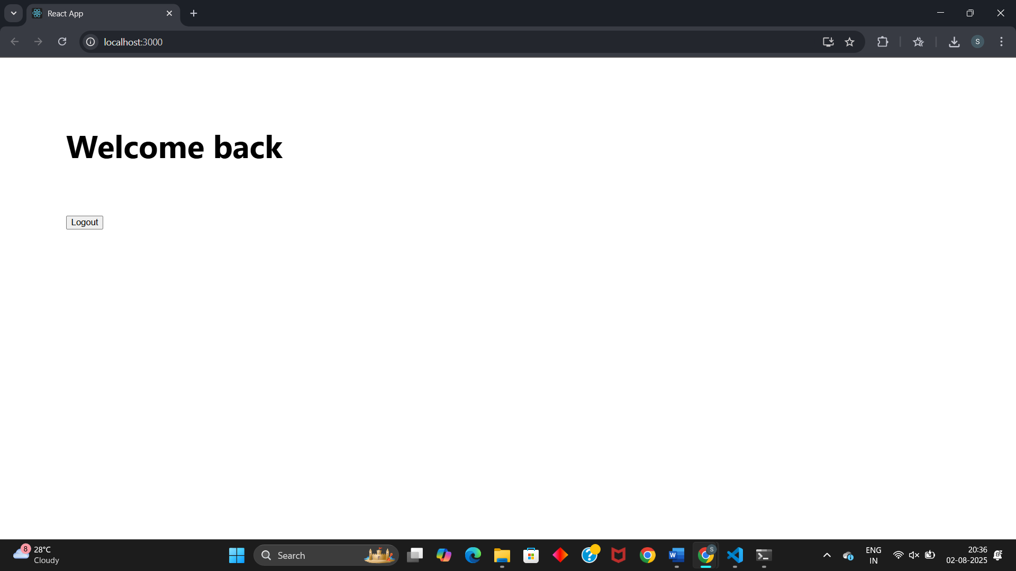

**EXERCISE 13: Blogger App**

**CODE:**

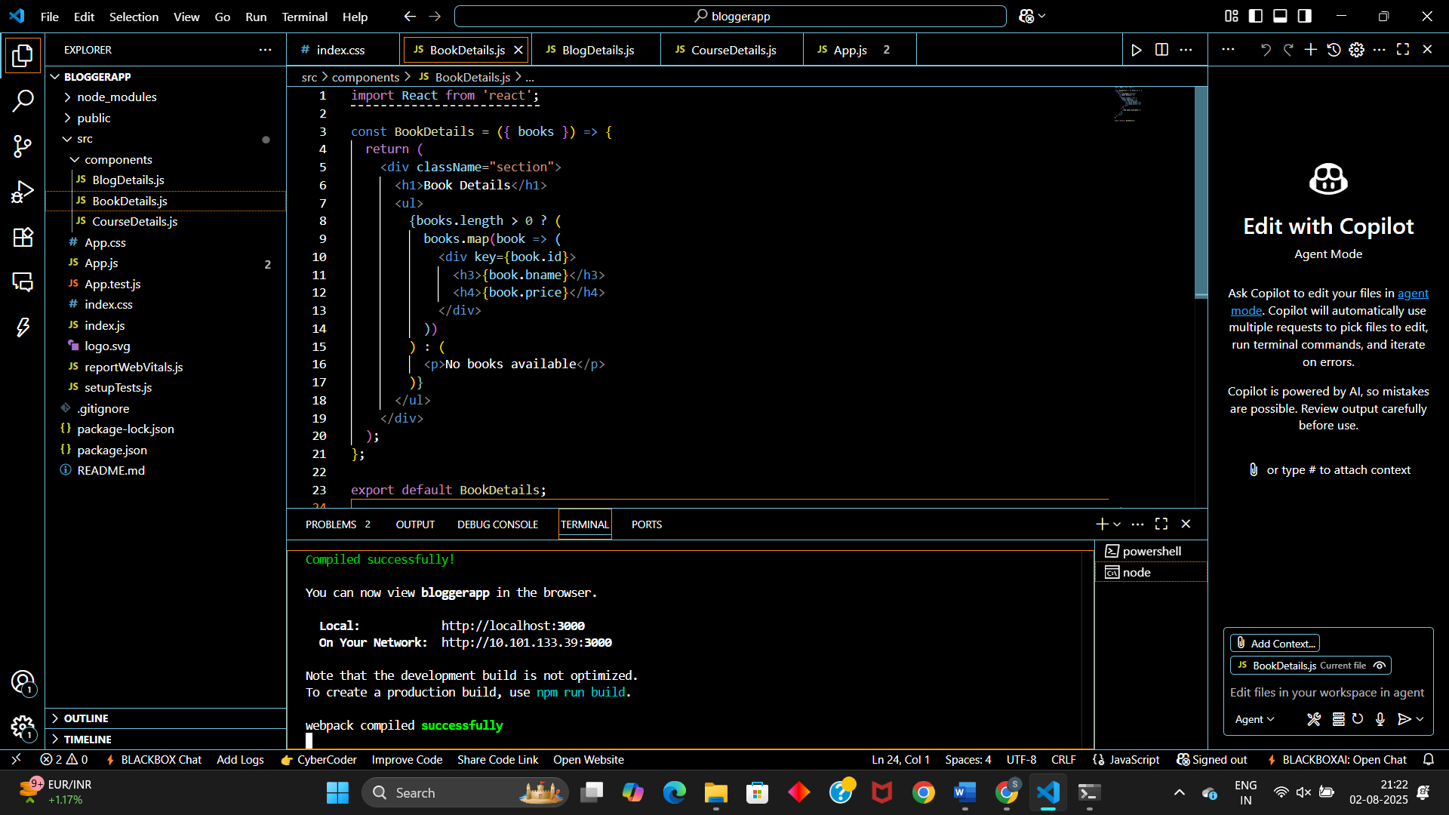

**BookDetails.js:**import React from 'react';

const BookDetails = ({ books }) => {

  return (

    <div className="section">

      <h1>Book Details</h1>

      <ul>

        {books.length > 0 ? (

          books.map(book => (

            <div key={book.id}>

              <h3>{book.bname}</h3>

              <h4>{book.price}</h4>

            </div>

          ))

        ) : (

          <p>No books available</p>

        )}

      </ul>

    </div>

  );

};

export default BookDetails;

**BlogDetails.js:**import React from 'react';

const BlogDetails = ({ blogs }) => {

  return (

    <div className="section">

      <h1>Blog Details</h1>

      {blogs.length > 0 ? (

        blogs.map((blog, index) => (

          <div key={index}>

            <h2>{blog.title}</h2>

            <h4><i>{blog.author}</i></h4>

            <p>{blog.content}</p>

          </div>

        ))

      ) : (

        <p>No blogs available</p>

      )}

    </div>

  );

};

export default BlogDetails;

**CourseDetails.js:**import React from 'react';

const CourseDetails = ({ courses }) => {

  return (

    <div className="section">

      <h1>Course Details</h1>

      {courses.length > 0 ? (

        courses.map((course, index) => (

          <div key={index}>

            <h2>{course.name}</h2>

            <p>{course.date}</p>

          </div>

        ))

      ) : (

        <p>No courses available</p>

      )}

    </div>

  );

};

export default CourseDetails;

**App.js:**import React from 'react';

import './index.css';

import BookDetails from './components/BookDetails';

import BlogDetails from './components/BlogDetails';

import CourseDetails from './components/CourseDetails';

const App = () => {

  const books = [

    { id: 101, bname: 'Master React', price: 670 },

    { id: 102, bname: 'Deep Dive into Angular 11', price: 800 },

    { id: 103, bname: 'Mongo Essentials', price: 450 },

  ];

  const blogs = [

    { title: 'React Learning', author: 'Stephen Biz', content: 'Welcome to learning React!' },

    { title: 'Installation', author: 'Schewzdenier', content: 'You can install React from npm.' },

  ];

  const courses = [

    { name: 'Angular', date: '4/5/2021' },

    { name: 'React', date: '6/3/20201' },

  ];

  return (

    <div className="container">

      <CourseDetails courses={courses} />

      <BookDetails books={books} />

      <BlogDetails blogs={blogs} />

    </div>

  );

};

export default App;

**Index.css:**body {

  font-family: sans-serif;

  margin: 50px;

}

.container {

  display: flex;

  justify-content: space-between;

}

.section {

  padding: 20px;

  border-left: 4px solid green;

  min-width: 30%;

}

.section h1 {

  font-size: 24px;

  font-weight: bold;

}

.section h2 {

  font-size: 20px;

}

.section h3 {

  font-size: 18px;

}

.section h4 {

  font-size: 16px;

  font-style: italic;

}

**RESULT:**

